FAST-NUCES KARACHI CAMPUS
(SPRING-2025)


CS3005 THEORY OF COMPUTATION

PROJECT TYPE: (SOFTWARE)

TITLE:
SUDUKO SOLVER – TURING MACHINE

SECTION: BCS-4A

INSTRUCTOR & PROJECT SUPERVISOR:
Dr. Nasir Uddin

PROJECT MEMBERS:
23K-0907 Zubair Ahmed
23I-0641 Aliyan Munawwar
23I-2527 Sidharat Sami D Mehraj
23I-2632 Fareed Aslam

[OVERVIEW]
This project is a web-based implementation of a Turing Machine (TM) designed to solve Sudoku puzzles, emphasizing concepts from the Theory of Computation. Visualizes how a multi-tape TM can algorithmically solve Sudoku using backtracking, state transitions, and tape operations.
[INTRODUCTION]
The simulator solves 9×9 Sudoku puzzles by modeling a deterministic multi-tape Turing Machine. It demonstrates:
- TM STATES: Scan, Try Value, Accept, and Reject.
- MULTI-TAPE ARCHITECTURE:
  - MAIN TAPE: Represents the Sudoku grid as a linear sequence.
  - FIXED TAPE: Tracks original puzzle values (immutable cells).
  - BACKTRACKING TAPES: Store trial positions and values for backtracking.
- VISUALIZATION: Real-time updates of the Sudoku grid, TM state diagram, tapes, and debug information.
[PROGRAMMING FEATURES]
- INTERACTIVE UI:
  - PRELOADED PUZZLES: (Easy/Medium/Hard/Expert).
  - CONTROLS: Step, Run, Reset, Solve Immediately.
  - Speed slider for animation (1–1000 ms/step).
  - CSS animations for tape head movement and Sudoku cell highlighting.
- STATE DIAGRAM:
  - SVG-based visualization of TM states (scan, try_value, accept, reject) & transitions
- TAPE VISUALIZATION:
  - MAIN TAPE: Scrollable cells showing current values and head position.
  - BACKTRACKING TAPE: Shows trial history (position & attempted values)
[APPLICATION LOGIC]
- TAPE INITIALIZATION & FIXED CELLS
Initializes tapes and marks fixed cells from the original puzzle:
class SudokuTuringMachine {
setTape(values) {
this.mainTape = [...values]; // Working tape
this.fixedTape = values.map(v => (v !== 0 ? v : 0)); // 0 = editable, non-zero = fixed
this.btPosTape = []; // Backtracking position history
this.btValTape = []; // Backtracking value history
this.headPos = 0; // Reset head
this.state = "scan";
}
}
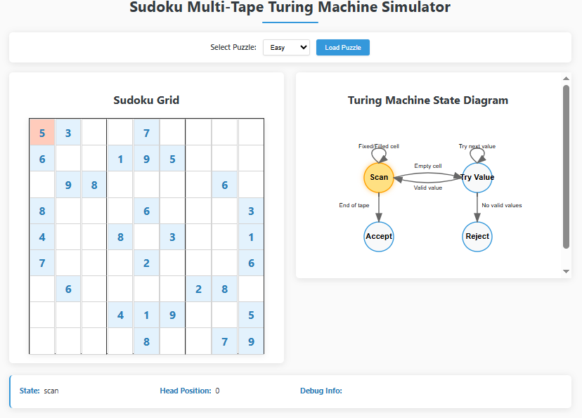
- BACKTRACKING VIA MULTI-TAPE TM
The TM uses backtracking to resolve conflicts, simulated through four tapes:
- MAIN TAPE: Current Sudoku state.
- FIXED TAPE: Original puzzle constraints.
- BACKTRACKING POSITION/VALUE TAPES: Track candidate values and positions during trials.
METHOD
class SudokuTuringMachine {
backtrack() {
while (this.btHeadPos >= 0) {
const [pos, val] = this.readBtTapes();
// Clear cells from backtracking position onward
for (let i = pos; i < this.mainTape.length; i++) {
if (this.fixedTape[i] === 0) this.mainTape[i] = 0;
}
this.headPos = pos;
this.state = "try_value";
const nextVal = val + 1;//Try next candidate value
if (nextVal > 9) continue; //Exhausted options
this.writeBtTapes(pos, nextVal);
return true;
}
this.state = "reject"; // No solution
}}
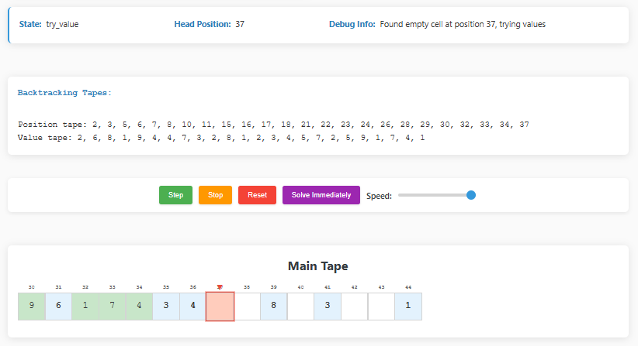
- STATE TRANSITIONS
- SCAN: Move head to find empty cells. Skip fixed/filled cells.
- TRY VALUE: Validate candidates (1–9) against Sudoku rules.
- ACCEPT/REJECT: Halt on solution or contradiction.
step() {
switch (this.state) {
case "scan":
if (this.readFixedTape() !== 0) this.headPos++;
else if (this.readMainTape() === 0) {
this.state = "try_value";
this.writeBtTapes(this.headPos, 1);//Start value 1
}
break;
case "try_value":
const [pos, val] = this.readBtTapes();
if (this.isValidPlacement(val)) {
this.writeMainTape(val);
this.headPos++;
this.state = "scan";
} else if (val < 9) {
this.moveBtHeadLeft();
this.writeBtTapes(pos, val + 1); // Try next value
} else this.backtrack(); // Backtrack if all values fail
break;
}}
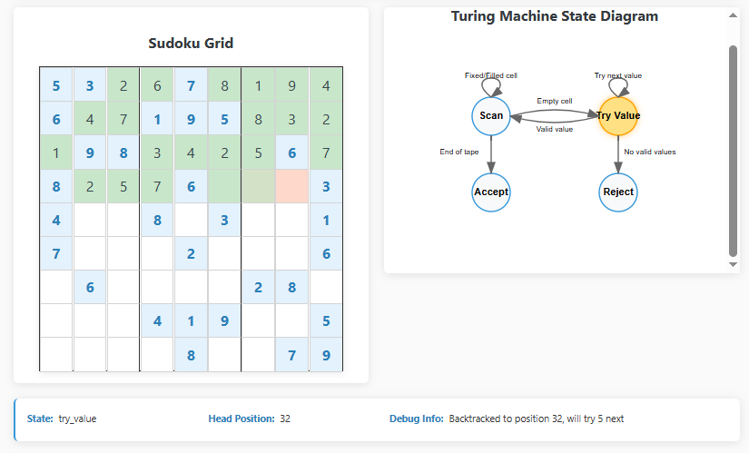
- IMMEDIATE SOLVE MECHANISM
Bypasses animation for instant solving:
class SudokuTMSimulator {
solveImmediately() {
const solveTm = new SudokuTuringMachine(); // Clone TM
solveTm.setTape(this.initialTape);
const success = solveTm.runToCompletion(1e9); // Max steps = 1 billion

if (success) {
this.tm.mainTape = [...solveTm.mainTape]; // Copy solution
this.tm.state = "accept";
this.updateDisplay();
}
}
}
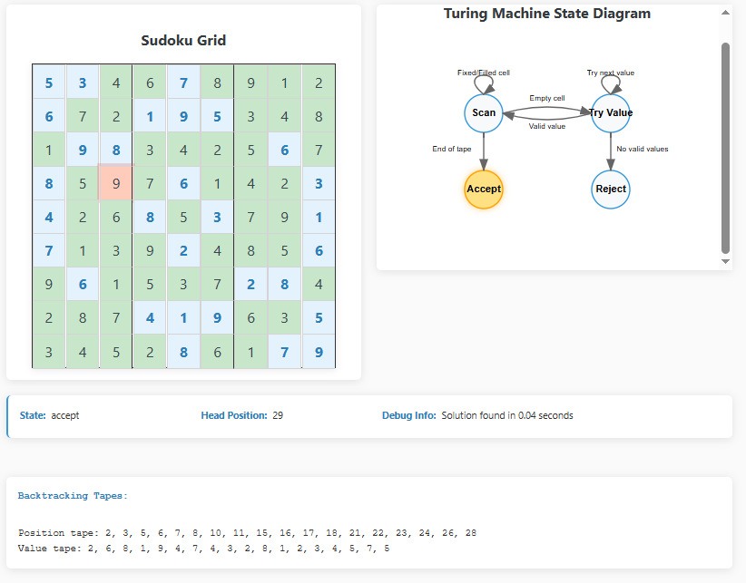

[UI COMPONENTS]
- SUDOKU GRID:
  - Cells styled as fixed (original puzzle) or filled (TM-generated).
  - Pulsing animation for the current tape head position.
- MAIN TAPE:
  - Displays 15 cells centered on the head position.
  - Head indicator (▼) and position labels.
- DEBUG PANEL:
  - Current state, head position, and backtracking tape contents.
- STATE DIAGRAM:
  - SVG nodes and edges updated dynamically using transitions like:
updateStateDiagram(svgElement, currentState) {
// Draw states and edges with labels
states.forEach(state => {
if (state.id === currentState) {
// Highlight current state node
}
});}

[LANGUAGES]
- FRONTEND: HTML5, CSS3 (Grid/Flexbox), SVG.
- LOGIC: Vanilla JavaScript (ES6 classes, event listeners).
- STYLING: CSS variables for themes, animations for user feedback.
[CONCLUSION]
This project bridges abstract TM concepts with practical Sudoku solving, demonstrating how computational models like Turing Machines can tackle constraint satisfaction problems. Its interactive design makes it suitable for educational use, illustrating backtracking, multi-tape operations, and state transitions in a visually engaging manner.

